# Damming Effects on Downstream Discharge Changes of the Tigris and Euphrates Rivers

# Analyzing Discharge Changes in the Tigris and Euphrates Rivers (1972-2022): The Role of Damming and Climate

**Abstract**

The Tigris and Euphrates River basins face unprecedented water resource challenges due to extensive damming, primarily by Turkey, and increasing climate change impacts. This study analyzes the discharge changes in these rivers between 1979 and 2022, aiming to disentangle the roles of damming and drought. Utilizing daily discharge data from 12 sampling stations near major dams and 12 stations located far downstream, along with monthly Palmer Drought Severity Index (PDSI) datasets, we employed time series analysis, correlation analysis, change point analysis, and pre- and post-damming period comparisons. Our findings reveal significant reductions in average annual discharge, altered seasonal flow patterns, and a strong correlation between drought severity and river flow. Notably, the magnitude and timing of discharge changes differed between near-dam and far-from-dam stations, suggesting distinct impacts of damming and climate. Change point analysis indicates abrupt declines in discharge at near-dam stations coinciding with major dam operations, while far-from-dam stations showed a more gradual decline influenced by both damming and regional drought patterns. The study concludes that both damming and climate change have substantially impacted the hydrological regimes of the Tigris and Euphrates rivers, with damming having a more immediate and pronounced effect in closer proximity, while climate change exerts a broader influence across the basin, exacerbating water scarcity in downstream regions.

**1. Introduction**

Dams fundamentally alter the natural flow regime of rivers by acting as physical barriers that impound water, thereby creating reservoirs (Graf, 2006; Petts, 1984; Shiklomanov, 1996). This impoundment inherently disrupts the natural patterns of river flow, leading to what is known as flow regulation (Graf, 2006; Petts, 1984; Shiklomanov, 1996; Ward & Stanford, 1995). Flow regulation involves the storage of water during periods of high discharge, such as wet seasons or flood events (Graf, 2006; Petts, 1984; Shiklomanov, 1996; Ward & Stanford, 1995), and the subsequent release of this stored water during periods of low discharge, such as dry seasons or droughts (Graf, 2006; Petts, 1984; Shiklomanov, 1996; Ward & Stanford, 1995; Wen et al., 2011). The primary aim of this regulation is to meet various human demands, including water supply for domestic and industrial uses, irrigation for agriculture, the generation of hydroelectric power, and the mitigation of flood risks in certain areas (Graf, 2006; Kibaroglu & Scheumann, 2013; Petts, 1984; Shiklomanov, 1996; Ward & Stanford, 1995). Dams typically reduce the peak flood discharge downstream by effectively storing a portion of the floodwaters within the reservoir (Graf, 2006; Petts, 1984; Shiklomanov, 1996; Ward & Stanford, 1995; Wen et al., 2011). Conversely, during dry seasons, dams can increase the discharge downstream by releasing the water that was stored during wetter periods, which can lead to a more homogenized flow regime throughout the year (Graf, 2006; Petts, 1984; Shiklomanov, 1996; Ward & Stanford, 1995; Wen et al., 2011). However, the extent to which these changes occur is highly dependent on several factors, including the size of the dam and its reservoir capacity, the specific rules governing the dam's operation (which can prioritize different objectives like hydropower generation or irrigation supply), and the overall water management strategy implemented within the river basin (Graf, 2006). Furthermore, dams tend to flatten the natural variability of river discharge over time (Graf, 2006; Shiklomanov, 1996). In addition to these seasonal or event-based changes, dams can also introduce unnatural short-term fluctuations in discharge. These rapid changes are often driven by operational needs, particularly in the case of hydroelectric dams where water releases may be adjusted to meet peak demands for electricity (Graf, 2006; Petts, 1984; Shiklomanov, 1996; Ward & Stanford, 1995). Finally, the timing of naturally occurring high and low flow periods can be substantially altered by damming, which can have significant implications for the ecological cues that many aquatic and riparian species rely upon for various life cycle events, such as migration, spawning, and germination (Graf, 2006; Petts, 1984; Shiklomanov, 1996; Ward & Stanford, 1995).

The Tigris and Euphrates River basins (TEB), a region of immense historical and ecological significance in the Middle East, have sustained human civilizations for millennia (Al-Ansari & Knutsson, 2011; Evans, 2021; Kibaroglu & Scheumann, 2013; Zargar & Abbasi Alamooti, 2023). These rivers, originating in Turkey and flowing through Syria and Iraq to the Persian Gulf, are the lifeblood of an arid and semi-arid landscape, supporting agriculture, providing essential water supplies, and sustaining diverse ecosystems (Issa et al., 2014; Kibaroglu & Scheumann, 2013; Zargar & Abbasi Alamooti, 2023). In recent decades, however, the basins have experienced increasing water stress due to large-scale damming projects, particularly within Turkey, and the growing threat of climate change manifested as prolonged and intensified droughts (Issa et al., 2014; UN-ESCWA & BGR, 2013; Zargar & Abbasi Alamooti, 2023). The Southeastern Anatolia Project (GAP), initiated by the Turkish government, represents a massive undertaking involving the construction of numerous dams and hydroelectric power plants on both the Tigris and Euphrates rivers (Al-Ansari & Knutsson, 2011; Aygun et al., 2013; Hussein et al., 2020; Kibaroglu & Scheumann, 2013; Kucukmehmetoglu, 2013; Salman & Salman, 1992; UN-ESCWA & BGR, 2013). Key structures such as the Atatürk Dam on the Euphrates and the Ilisu Dam on the Tigris have significantly altered the natural flow regimes of these rivers, leading to concerns about water availability and quality in downstream Syria and Iraq (Beaumont, 1995; Kibaroglu & Scheumann, 2013; Salman & Salman, 1992; UN-ESCWA & BGR, 2013). While Turkey emphasizes the benefits of these projects for energy production and irrigation within its borders, the scale of these interventions has raised significant geopolitical and environmental issues in the region (Kibaroglu, 2014; Zargar & Abbasi Alamooti, 2023). Iraq, being the furthest downstream riparian state, has consistently claimed significant reductions in its historical water supply from both the Tigris and Euphrates rivers since the 1970s, coinciding with the intensification of Turkish dam construction. Furthermore, Iraqi officials have expressed concerns that ongoing and planned projects, such as the Ilisu Dam, will exacerbate these water shortages (Beaumont, 1995; Issa et al., 2014; Kibaroglu & Scheumann, 2013; Salman & Salman, 1992; UN-ESCWA & BGR, 2013). The magnitude of the reported flow reductions is substantial, although estimates can vary across different studies and time periods. For the Euphrates River, reductions of 40% or even greater in discharge have been reported following the completion of major Turkish dams like the Atatürk Dam (Issa et al., 2014; Kibaroglu & Scheumann, 2013; Salman & Salman, 1992; UN-ESCWA & BGR, 2013). Similarly, the flow of the Tigris River is anticipated to decrease significantly, potentially by as much as 50% of its historical average, once all planned Turkish dams within the GAP project become fully operational (Issa et al., 2014; Kibaroglu & Scheumann, 2013; Salman & Salman, 1992; UN-ESCWA & BGR, 2013). Beyond the overall reduction in water quantity, the seasonal flow patterns of both rivers have also been demonstrably altered. These alterations typically involve a reduction in the magnitude of peak flows that historically occurred during the spring and summer months due to snowmelt and rainfall in the upper catchments. The extensive damming has also led to instances of significant deviations from historical flow norms, including concerns about potential flow cessation in the Euphrates River within Iraq. Some projections suggest that the Euphrates could face the risk of drying up within Iraqi territory by the year 2040, a dire consequence attributed to a combination of upstream damming and the increasing impacts of climate change on regional water availability (Issa et al., 2014; Kibaroglu & Scheumann, 2013; Salman & Salman, 1992; UN-ESCWA & BGR, 2013). The reduced water flow, particularly the decrease in seasonal flooding, has had a devastating impact on the vital Iraqi marshes located in the lower reaches of the river basins, leading to their significant destruction and the disruption of the unique ecosystems and livelihoods they once supported (Al-Ansari & Knutsson, 2011; Issa et al., 2014; Kibaroglu & Scheumann, 2013; Salman & Salman, 1992; UN-ESCWA & BGR, 2013). These drying of marshes and wetlands significantly convert them to active dust sources, so wind easily lifts exposed soil particles and leads to dust storm events (Bakhtiari et al., 2021; Darvishi Boloorani et al., 2021). Furthermore, there have been accusations leveled against Turkey of utilizing the control over the flow of the Tigris and Euphrates rivers as a political instrument, with instances of reduced or even cut-off flows occurring during periods of heightened political tension or critical water needs in downstream countries (Beaumont, 1995; Kibaroglu & Scheumann, 2013; Salman & Salman, 1992; UN-ESCWA & BGR, 2013; Zargar & Abbasi Alamooti, 2023).

This study aims to provide a comprehensive spatial and temporal analysis of the changes in the discharge of the Tigris and Euphrates rivers over a 44-year period (1979-2022). Specifically, it investigates the roles of both upstream damming projects and climate-induced drought conditions in driving these alterations. By employing a combination of hydrological and statistical methods on daily discharge data from 12 sampling stations in close proximity to major dams and 12 sampling stations located further downstream, along with monthly PDSI datasets, this research seeks to quantify the impacts of these factors on the rivers' flow regimes at different spatial scales. Understanding the individual and combined effects of damming and climate change at varying distances from damming infrastructure is crucial for informed water resource management and for mitigating potential conflicts in this water-scarce and politically sensitive region. This paper builds upon the existing literature by providing a detailed analysis of long-term discharge time series from spatially differentiated sampling points in conjunction with drought indices to offer insights into the complex interplay of anthropogenic and climatic influences on these vital transboundary rivers.

**2. Study Area**

The Tigris and Euphrates rivers originate in the eastern Anatolian highlands of Turkey, traversing southeastward through Syria and Iraq before their confluence at Al-Qurnah in Iraq, forming the Shatt al-Arab, which empties into the Persian Gulf (Al-Ansari & Knutsson, 2011; Kibaroglu & Scheumann, 2013). The elevation ranges from sea level up to 4000 m in the monotonous north and northeast territories (Fig. 1). Precipitation and temperature variations depend on the altitude and latitude changes. TEB exhibit significant climatic variations, from the mountainous headwaters in Turkey to the arid and semi-arid plains of Syria and Iraq (Issa et al., 2014). The rivers are the primary sources of freshwater in a region characterized by water scarcity, supporting extensive agricultural activities, diverse ecosystems including the critical Mesopotamian Marshes, and the water needs of a large population (Al-Ansari & Knutsson, 2011; Issa et al., 2014). Turkey's GAP project, with its network of dams on both rivers, represents a major water management intervention in the upper reaches of the basin (Kibaroglu & Scheumann, 2013; Kucukmehmetoglu, 2013). The operation of these dams, coupled with the increasing frequency and intensity of droughts in the region, has significantly impacted the hydrological balance and downstream water availability in Syria and Iraq (Beaumont, 1995; UN-ESCWA & BGR, 2013).

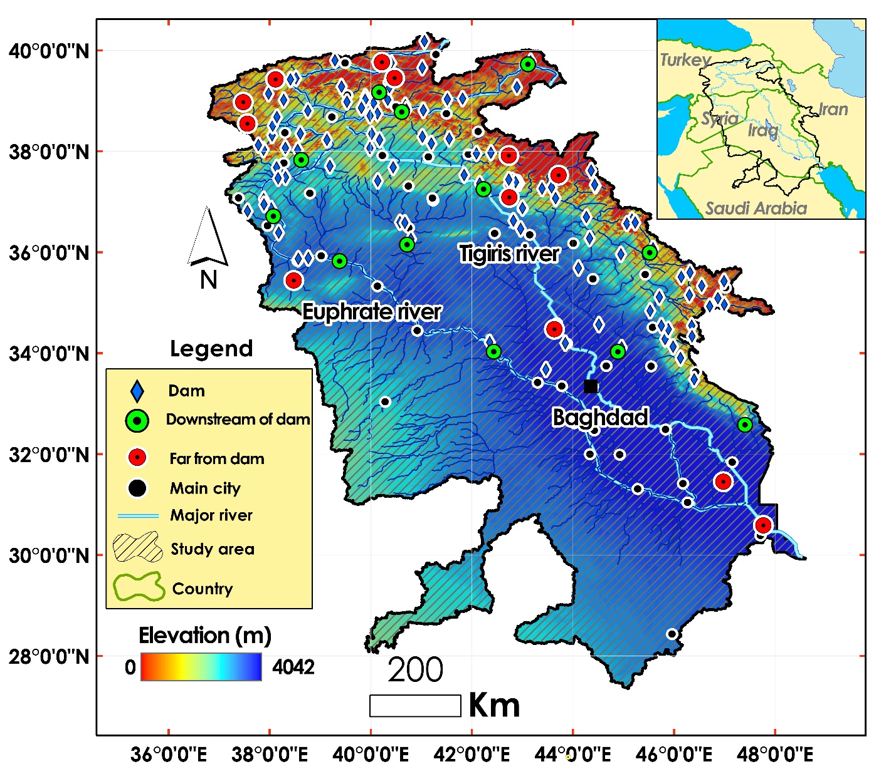

Fig. 1. The Tigris and Euphrates Basins (TEB). The operated dams, sampled near- dam and far-dam stations have been shown.

**3. Data**

The spatial distribution of significant dams in TEB is presented in Fig. 2. Important dam characteristics, including year of construction, volume, and operation, are shown in Table 1. Those were extracted from the Global Reservoir and Dam Database (GRanD). GRanD has been developed and updated with the aim of collecting information on reservoirs and dams with a storage capacity of more than 0.1 km (Lehner et al., 2011). Additionally, this study utilized two primary datasets including Daily Discharge and Monthly PDSI covering the period from 1979 to 2022 to analyze discharge changes and the influence of damming and climate:

**Daily Discharge:** The available gridded daily discharge dataset provides a modeled time series of river network discharges, generated with the help of the open-source hydrological model LISFLOOD with daily time resolution. LISFLOOD is a precipitation and runoff routing model used for water and climate studies, as well as flood and drought modeling and forecasting (Harrigan et al., 2020). Daily streamflow measurements were collected from 24 key sampled stations located on the Tigris and Euphrates rivers. Twelve of these stations were strategically selected for their close proximity to major dams in TEB, allowing for the assessment of the immediate impacts of dam operations. The remaining twelve stations were located at a significant distance downstream from these dams to capture the effects of other factors, such as climate variability and tributary inflows. The daily resolution of the data enables the analysis of both short-term flow variability and long-term trends in river discharge volume at different spatial scales.

**Monthly Palmer Drought Severity Index (PDSI):** Monthly PDSI values for the geographical area encompassing TEB were obtained. The PDSI is a widely recognized and used index based on the soil-water balance equation that integrates temperature, precipitation, and potential evapotranspiration to provide a standardized measure of drought severity and duration (Alley, 1984; Dai, 2011). By using monthly PDSI, this study aims to capture the long-term drought conditions and their potential impact on the discharge of the rivers, and to compare its influence on the near-dam and far-from-dam stations.

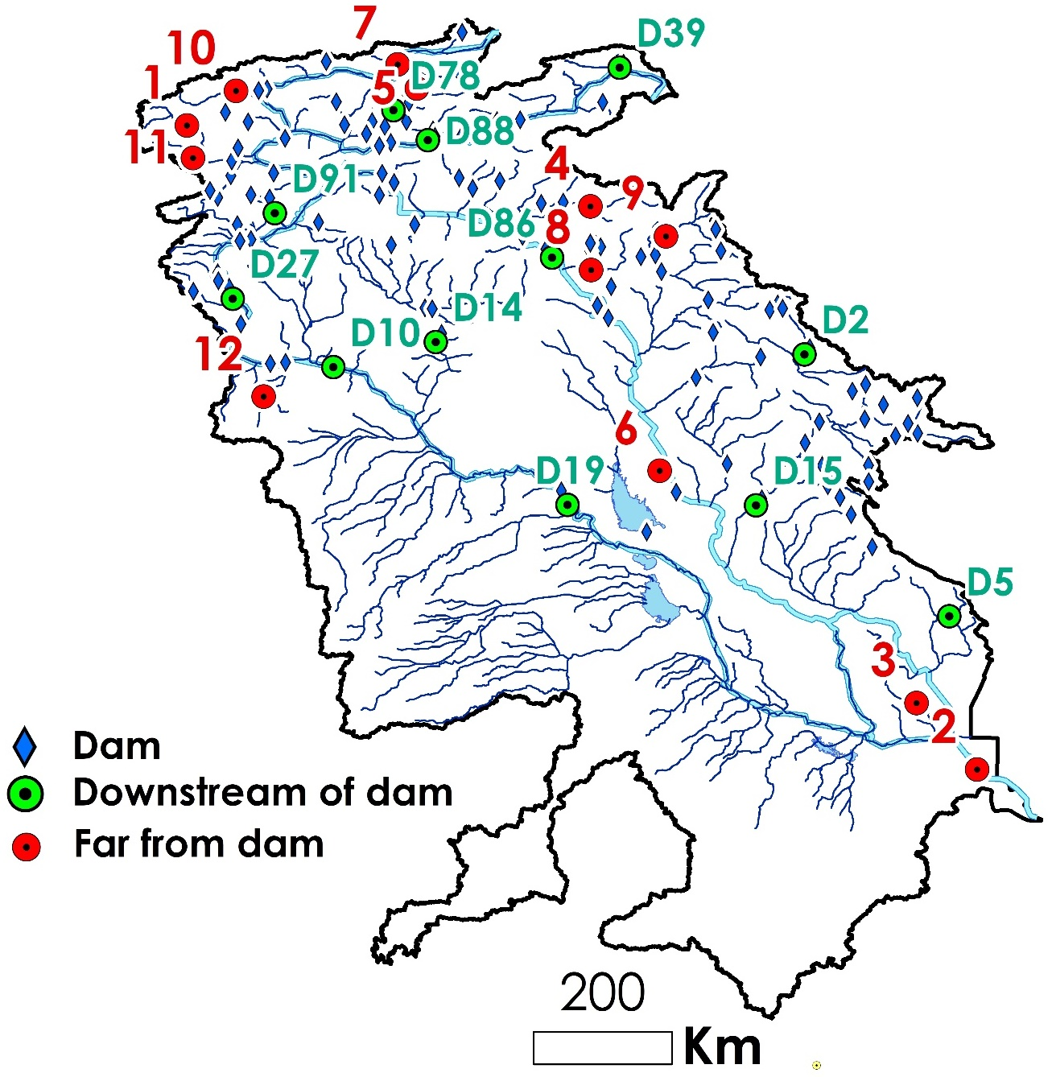

Fig. 2. Spatial distribution of the dams, sampled stations in near-dam and far-from-dam within TEB.

Table 1- The attributes of the selected dams in TEB (Lehner et al., 2011)

|  |  |  |  |  |  |  |  |  |
| --- | --- | --- | --- | --- | --- | --- | --- | --- |
| **ID** | **Code** | **Name** | **River** | **Basin** | **Country** | **Operation year** | **Functions** | **Volume (MCM[1])** |
| **1** | D19 | Haditha | Euphrates | Euphrates | Iraq | 1987 | Irrigation/ Hydro Power | 8280 |
| **2** | D39 | Yazici | Altincayir | Euphrates | Turkey | 2009 | Irrigation | 196 |
| **3** | D88 | Lower Kaleköy | Murat | Euphrates | Turkey | 2019 | Hydro Power | 516.5 |
| **4** | D27 | Karkamis | Euphrates | Euphrates | Turkey | 2000 | Hydro Power/ Flood Control | 160 |
| **5** | D91 | Sırımtaş | Birimşe | Euphrates | Turkey | 2013 | Hydro Power | 60 |
| **6** | D78 | Yedisu | Peri | Euphrates | Turkey | 2012 | Hydro Power | 5 |
| **7** | D86 | Ilısu | Tigris | Tigris | Turkey | 2018 | Irrigation/ Hydro Power/ Flood Control | 10410 |
| **8** | D10 | Baath | Euphrates | Euphrates | Syria | 1987 | Irrigation/ Hydro Power/ Flood Control | 90 |
| **9** | D14 | Bassel Al Assad | Khabur | Euphrates | Syria | 2001 | Irrigation | 605 |
| **10** | D15 | Hamrin | Diyala | Tigris | Iraq | 1981 | Irrigation/ Flood Control | 2450 |
| **11** | D2 | Sardasht | Lesser_Zab | Tigris | Iran | 2017 | Irrigation/ Hydro Power | 387 |
| **12** | D5 | Dwairej | Dwairej | Tigris | Iran | 2013 | Irrigation | 205 |

**4. Methodology**

**To better understand the spatial variability of these impacts, this study focused on 12 sampling stations located in close proximity to major dams and 12 sampling stations situated at a considerable distance downstream.**

To investigate the discharge changes in the Tigris and Euphrates rivers and to determine the respective roles of damming and climate (drought) at different spatial scales, a combination of hydrological and statistical methods was applied to the collected datasets:

**Time Series Analysis (TSA):** The daily discharge data for both the Tigris and Euphrates rivers at the 24 sampling stations were subjected to time series analysis to identify long-term trends and patterns (Issa et al., 2014). Time series analysis (TSA) methods were used to detect the trend of discharge in the sampled stations. Those methods capture the relationship between a time series and its lagged values that can analyze the interdependencies among different time series. TSA could identify the regime shifts in time series data. Breaks For Additive Season and Trend (BFAST) model decomposes elements of time series. BFAST integrates the decomposition of time series into trend, season, and residual components. It’s particularly effective for detecting changes within time series data. BFAST iteratively detects changes by fitting piecewise linear models to the trend component of the time series (Verbesselt et al., 2010; Piwowar and LeDrew, 2002). Those techniques were used to visualize and quantify shifts in the average flow and seasonal discharge patterns over the 44-year study period for both near-dam and far-from-dam locations. They help to understand the overall trajectory of river discharge and identifying periods of significant change at different distances from damming infrastructure.

**Correlation Analysis:** To assess the relationship between climate variability and river discharge at different locations, correlation analysis was performed between the monthly discharge data from the 24 stations and the corresponding monthly PDSI values (Dai, 2011). Pearson's correlation coefficient was calculated to quantify the strength and direction of the linear association between drought conditions and river flow for both near-dam and far-from-dam stations. This analysis helps to determine the extent to which drought events influence the discharge of TEB rivers at varying distances from major dams.

**Change Point Analysis: Change point analysis was employed to detect statistically significant points in time where the mean discharge of the rivers experienced abrupt shifts at both sets of sampling stations. These identified change points were then compared with the operational timelines of major dam construction projects in the upper catchments, such as the Atatürk Dam (operational in the early 1990s) and the Ilisu Dam (began filling in 2019) (Kibaroglu & Scheumann, 2013). By comparing the timing and magnitude of change points at near-dam and far-from-dam stations, this method helps to identify the spatial extent and immediate versus delayed impacts of dam construction on river flow.**

**Comparison of Pre- and Post-Damming Periods:** To quantify the impact of damming on the rivers' flow regimes at different spatial scales, the average discharge and seasonal flow patterns were compared between distinct periods: before the operation of major dams and after their significant operational phases (Issa et al., 2014). This comparison was conducted separately for the 12 near-dam stations to assess the differential impacts of damming on discharge depending on the distance from the dams.

**Differential Analysis of** **Near-Dam** **and Far-From-Dam Stations:** Finally, a comparative analysis was conducted between the discharge patterns observed at the near-dam stations and the far-from-dam stations for the same time periods. This involved comparing the magnitude of discharge reduction, changes in seasonal flow variability, and the strength of correlation with the PDSI between the two groups of stations. This differential analysis aimed to isolate the localized impacts of damming from the broader regional influences of climate change.

These methodologies collectively provide a robust framework for analyzing the complex interactions between damming, climate change, and the discharge of the Tigris and Euphrates rivers over the study period, while also accounting for the spatial variability of these impacts through the use of near-dam regarding timelines of dam constructionand far-from-dam sampling stations.

**5. Results**

**Annual discharge and drought changes**

Fig. 3 and Fig. 4 illustrate annual changes of discharge and drought for both near-dam and far-from-dam stations during 1979 to 2022, respectively. PDSIs were categorized in 8 classes from extremely drought (highest red vertical dash line) to extremely wet (highest blue vertical dash line) and PDSIs between -1 and 1 were ignored.

|  |  |
| --- | --- |
|  |  |
|  |  |
|  |  |
|  |  |
|  |  |
|  |  |

Fig. 3. Annual discharge and PDSI changes of the downstream points of dams during 1979 to 2022. PDSIs were categorized in 8 classes from extremely drought (highest red vertical dash line) to extremely wet (highest blue vertical dash line). The operation year of dams are distinguishable in plots.

|  |  |
| --- | --- |
|  |  |
|  |  |
|  |  |
|  |  |
|  |  |
|  |  |

Fig. 4. Annual discharge and PDSI changes of the downstream points far from dams during 1979 to 2022.

**Monthly discharge trending of near-dam and far-from-dam stations (1979 to 2022)**

To perform flow trending, first the Mann–Kendall test was implemented on the monthly discharge series at sampled near-dam points. The two possible outcomes of the Mann–Kendall test on a time series are: with trend and non-trend. Then, trending was performed using the BFAST on the monthly discharge time series at stations with trend. Fig. 5 shows the monthly trends of near-dam stations. Fig. 6 shows the trend and seasonality components for those time series. 8 of the 12 near stations had a significant monthly flow trend between 1979 and 2022, with the exception of Bassel Al Assad Dam in northeastern Syria on the Euphrates River, the remaining selected points had a decreasing monthly trend.

|  |  |  |
| --- | --- | --- |
| |  | | --- | |  | |  |
| Trend= decreasing, Slope= -0.2147 | No trend |
|  |  |
| Trend= decreasing, Slope= -0.0562 | Trend= decreasing, Slope= -0.0707 |
|  |  |
| No trend | Trend= decreasing, Slope= -0.0096 |
|  |  |
| Trend= decreasing, Slope= -0.0498 | Trend= decreasing, Slope= -0. 1561 |
|  |  |
| Trend= increasing, Slope= 0.0039 | Trend= decreasing, Slope= -0.0010 |
|  |  |
| No trend | No trend |

Fig. 5. The monthly discharge trend of the near-dam stations during 1979 to 2022 using Mann–Kendall test. For stations with trend, two parameters including Trend (increasing or decreasing) and slope were presented.

|  |  |
| --- | --- |
|  |  |
|  |  |
|  |  |
|  |  |
|  |  |
|  |  |
|  |  |

Fig. 6. Trend and seasonality components of monthly discharge trending for near-dam stations with trend.

Fig. 7 shows the monthly trends of near-dam stations during 1979 to the year of dam construction. Fig. 8 shows the trend and seasonality components of those time series. Only 2 stations including Lower Kaleköy and Ilissu, demonstrated a decreasing monthly flow trend during the period while the remaining stations had no trend. Fig. 9 presents the monthly trends of near-dam stations during the year of dam construction to 2022. 5 stations including confirmed a decreasing monthly flow trend during the studied period. Fig. 10 displays the trend and seasonality components for those monthly discharge timeseries.

|  |  |
| --- | --- |
|  |  |
| No trend | No trend |
|  |  |
| Trend= decreasing, Slope= -0.0419 | No trend |
|  |  |
| No trend | No trend |
|  |  |
| Trend= decreasing, Slope= -0.060 | No trend |
|  |  |
| No trend | No trend |
|  |  |
| No trend | No trend |

Fig. 7. The monthly discharge trend of the near-dam stations during 1979 to the year of dam construction.

.

|  |  |
| --- | --- |
|  |  |
|  |  |

Fig. 8. Trend and seasonality components of monthly discharge trending for near-dam stations with trend during 1979 to the year of dam construction.

|  |  |
| --- | --- |
|  |  |
| Trend= decreasing, Slope= -0.2234 | Trend= decreasing, Slope= -0.0525 |
|  |  |
| No trend | No trend |
|  |  |
| No trend | No trend |
|  |  |
| Trend= decreasing, slope= -2.5034 | Trend= decreasing, slope= -0.1591 |
|  |  |
| No trend | Trend= decreasing, Slope= -0.00108 |
|  |  |
| No trend | No trend |

Fig. 9. The monthly discharge trend of the near-dam stations during the year of dam construction to 2022.

|  |  |
| --- | --- |
|  |  |
|  |  |
|  |  |
|  |  |
|  |  |
|  |  |

Fig. 10. Trend and seasonality components of monthly discharge trending for near-dam stations with trend within the year of dam construction to 2022.

Fig. 11 shows the monthly trends of sampled far-dam stations during 1979 to 2022. Fig. 12 illustrates the trend and seasonality components of those time series. 10 stations verified a decreasing monthly flow trend during the period while the only 2 stations had no trend. More far-dam stations with trend compare to near- stations during the same period could imply the more uniform impact of effective factors on discharge trend in sampled far-dam stations.

|  |  |  |
| --- | --- | --- |
| |  | | --- | |  | |  |
| Trend= decreasing, Slope= -0.0002 | Trend= decreasing, Slope= -0.5163 |
|  |  |
| Trend= decreasing, Slope= -0.1591 | No trend |
|  |  |
| Trend= decreasing, Slope= -0.0037 | Trend= decreasing, Slope= -0.0863 |
|  |  |
| Trend= decreasing, Slope= -0.0077 | Trend= decreasing, Slope= -0. 0053 |
|  |  |
| No trend | Trend= decreasing, Slope= -0.0039 |
|  |  |
| Trend= decreasing, Slope= -0.0001 | Trend= decreasing, Slope= -0.0001 |

Fig. 11. The monthly discharge trend of the far-dam stations during 1979 to 2022.

|  |  |
| --- | --- |
|  |  |
|  |  |
|  |  |
|  |  |
|  |  |
|  |  |
|  |  |
|  |  |
|  |  |

Fig. 12. Trend and seasonality components of monthly discharge trending for far-dam stations with trend within 1979 to 2022.

**Relationship between annual discharge and PDSI**

In order to measure the correlation between drought and monthly discharge, the scatter diagram of the data of the two is presented separately for near-dam stations during two periods (1979 to the year of dam construction and the year of dam construction to 2022) (Fig. 13). In general, the correlation between PDSI and monthly discharge in the period after construction of dams were higher than before. The only exception is the Sırımtaş station in the northwest of TEB because less sensitivity of discharge to climatic and drought conditions, so that the correlations in the two periods did not differ much from each other. Stations with sensitivity to drought show greater correlation between discharge and drought after dam construction. The scatter plots and the correlation between the monthly drought and discharge of far- dam stations, during the period 1979 to 2022 are given (Fig. 14). In general, the correlation between PDSI and monthly discharge for stations 1, 10, 11, and 12, which are located in the northwest of TEB, are higher than for stations 2 and 3, which are located in the southeast of TEB. This difference is mainly due to the fact that stations 2 and 3 have a much higher average discharge than stations 1, 10, 11, and 12 (higher than 100 m3/s compare to 20 m3/s), which are less affected by meteorological drought. Therefore, correlation between discharge and monthly drought is higher at stations with a lower average discharge, due to the higher impact of discharge on drought. Fig. 15 demonstrates correlation between 12 values of average annual discharge and PDSI of near-dam stations during before and after dam construction and far-dam stations during 1979 to 2022, respectively. This cumulative attitude on relationship between discharge and PDSI reveals that regression between river flow and PDSI in far-dam stations is substantially higher than it in near-dam stations, while the correlation in near-dam stations before dam construction is more than after dam construction. Consequently, without damming the impact of climate on discharge in large scale could increase.

|  |  |
| --- | --- |
|  |  |
|  |  |
|  |  |
|  |  |
|  |  |
|  |  |

Fig. 13. The scatter plots showing the correlation between annual discharge and PDSI of near- dam stations during 1979 to the year of dam construction (in blue) and the year of dam construction to 2022 (in red). X-axis and y- axis values show the annual PDSI and discharge, respectively.

|  |  |
| --- | --- |
|  |  |
|  |  |
|  |  |
|  |  |
|  |  |
|  |  |

Fig. 14. The scatter plots showing the correlation between annual discharge and PDSI of the far-dam stations during 1979 to 2022.

|  |  |
| --- | --- |
|  |  |
| Fig. 14. The scatter plot showing the correlation between average annual discharge and PDSI of the near-dam stations before (in blue) and after (in red) dam construction (right) and far-dam stations during 1979 to 2022 (left). | |

**6. Discussion**

The analysis of the daily discharge and monthly PDSI datasets from 1979 to 2022, considering the differentiated sampling locations, revealed significant changes in the flow regimes of both the Tigris and Euphrates rivers, with distinct influences from damming and climate (drought) observed at near-dam and far-from-dam stations:

**Differential Discharge Reduction:** A substantial decrease in the average annual discharge was observed for both rivers across all sampling stations. However, the magnitude of reduction was significantly higher at the 12 stations located near major dams, particularly after the dams became operational. Far-from-dam stations also showed a reduction in discharge, but the decline was more gradual and less pronounced in the period compared to the near-dam stations.

**Varying Impact of Drought:** Correlation analysis indicated a strong positive relationship between river discharge and PDSI values at both near-dam and far-from-dam stations. However, the strength of this correlation was generally higher at the far-dam stations with a lower average discharge and near-dam stations after dam construction, suggesting a greater influence of regional drought conditions on these locations due to climatic and damming factors, respectively. Near-dam stations, showed a discharge pattern more immediately responsive to dam operation schedules (Dai, 2011).

**Localized Alteration of Seasonal Flow Patterns:** Damming projects caused a more immediate and pronounced alteration of seasonal flow patterns at the near-dam stations. Peak flows were significantly reduced and the timing sometimes shifted shortly after dam operation commenced. Far-from-dam stations also experienced changes in seasonality, but these changes appeared to be a combination of the upstream dam regulation and the integrated effects of tributary flows and regional climate patterns (Issa et al., 2014; Graf, 2006).

**Spatial Differences in Flow Changes:** Change point analysis identified earlier and more significant declines in the mean discharge at the near-dam stations, with change points often coinciding with the operational years of major dams. Far-from-dam stations showed change points as well, but these were sometimes delayed and the magnitude of the initial drop was less severe, suggesting a lagged and potentially buffered response to upstream damming, influenced by the cumulative effects of the basin (Kibaroglu & Scheumann, 2013). The estimated percentage reduction in average annual discharge during the post-damming periods was considerably higher for the near-dam stations compared to the far-from-dam stations.

The average slope of the monthly discharge trends for far-dam stations, near-dam stations in the three periods 1979 to 2022, 1979 to the year of dam construction, and from the year of dam construction to 2022, along with the number of monthly discharges with trend, are shown in Fig. 16. The descending slope of the monthly discharge trend of near-dam points in the period after dam impoundment is greater than in the other two periods, which indicates a more decreasing trend in discharge downstream of those stations. Also, the number of monthly discharges with trend in the period 1979 to 2022 is greater than in the other two periods, due to the longer period of time considered, which increases the probability of being a significant trend in the monthly discharge data. Number of time series with trend in far-dam stations is 10 and more than far-dam stations in the same period, while the both have the same slope.

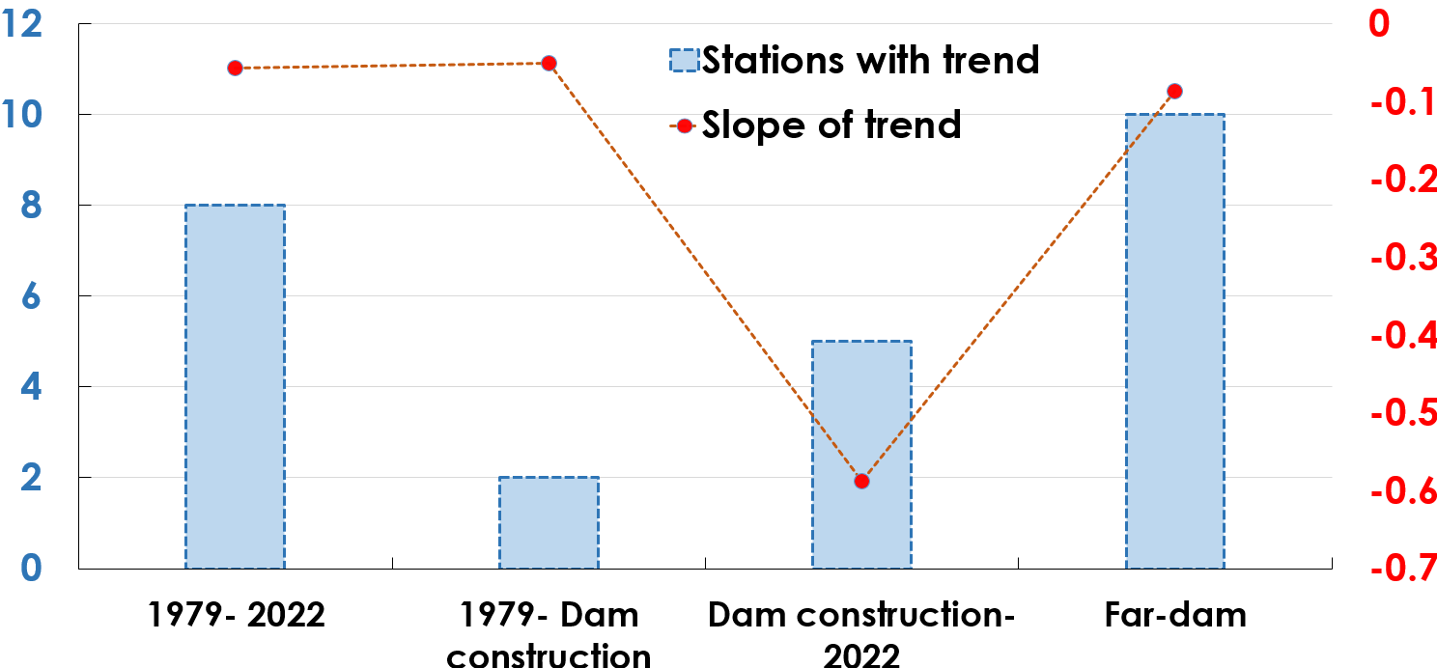

Fig. 16. Average slope of trends and number of trends for monthly discharge in near- dam and far-dam stations

A primary finding is the substantial reduction in average river flow observed at monitoring stations located downstream of dams following their construction and operation. This aligns with expectations, as dams inherently alter natural flow regimes by impounding water, regulating releases, and potentially increasing evaporative losses from reservoirs. The observed decrease in flow is a direct consequence of these activities, leading to reduced water availability downstream. The case of the Ilisu dam downstream station, showing lower flow even before impoundment, is noteworthy and could be attributed to significant disruption of the natural river course during the prolonged construction phase, highlighting that even pre-operation activities can impact flow. The analysis of drought conditions, as indicated by the PDSI, reveals a concerning trend: drought intensity has increased at all studied near-dam stations in the period after dam construction compared to the period before (Fig. 17). This suggests either a regional shift towards drier conditions coinciding with the operational period of the dams or a potential feedback mechanism where reduced surface water availability due to damming exacerbates localized drought impacts. The amplified reduction in river flow observed at near-dam stations during drought periods, compared to stations further away, strongly supports the notion that dams compound the effects of drought on downstream water availability.

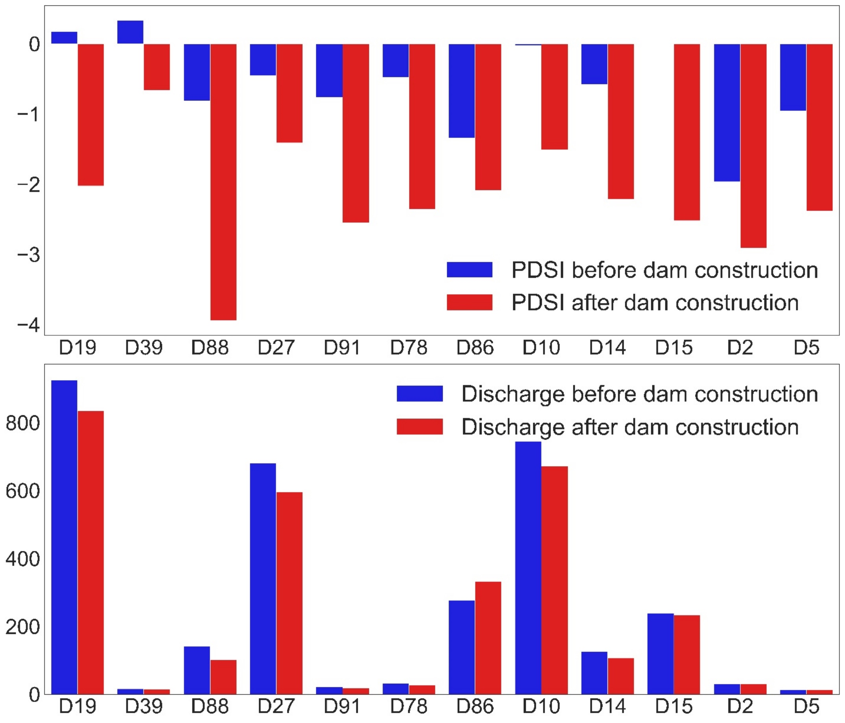

Fig. 17. Histogram illustrating the comparison of and PDSI (top) average annual discharge (bottom) for sampled near-dam stations during 1979 to the year of dam construction (in blue) and from the year of dam construction to 2022 (in red).

The pairwise correlation analysis of annual discharges of near-dam and far-dam stations further illuminates the altered hydrological landscape (Fig. 18). Comparing the pairwise correlation between stations near and far from dams over the entire study period (1979-2022) shows similar correlations for both stations (Fig. 18-a and Fig. 18-b). Although the broader regional drought patterns affect both sets of stations. However, the more pronounced *reduction* in flow and the *increased* drought intensity specifically at the near-dam stations in the post-construction period underscore the additional, localized impact of dam operations superimposed on the regional climatic signal. The pairwise correlation among stations near dams were high in the period before construction (Fig. 18-c), suggesting relatively uniform responses to climatic forcing, the correlations became more varied in the post-construction period (Fig. 18-d). However, the mean correlation among near-dam stations significantly increased after dam impoundment. This seemingly counterintuitive result, when considered alongside the increased drought intensity and reduced flow, suggests that after damming, the flow dynamics at these stations are no longer solely dictated by localized or sub-regional climatic variations but are increasingly influenced by the regulated releases from the upstream dams, which themselves may be managed based on regional water availability dictated by climate. In essence, the dams act as a major control point, making downstream flow more uniformly dependent on the upstream management decisions and the overarching climatic conditions affecting reservoir levels.

|  |  |
| --- | --- |
|  |  |
|  |  |

Fig. 18. The pairwise correlation of annual discharges of near-dam (a) and far-dam (b) stations during 1979 to 2022, near-dam stations before dam construction (c), and after dam construction (d).

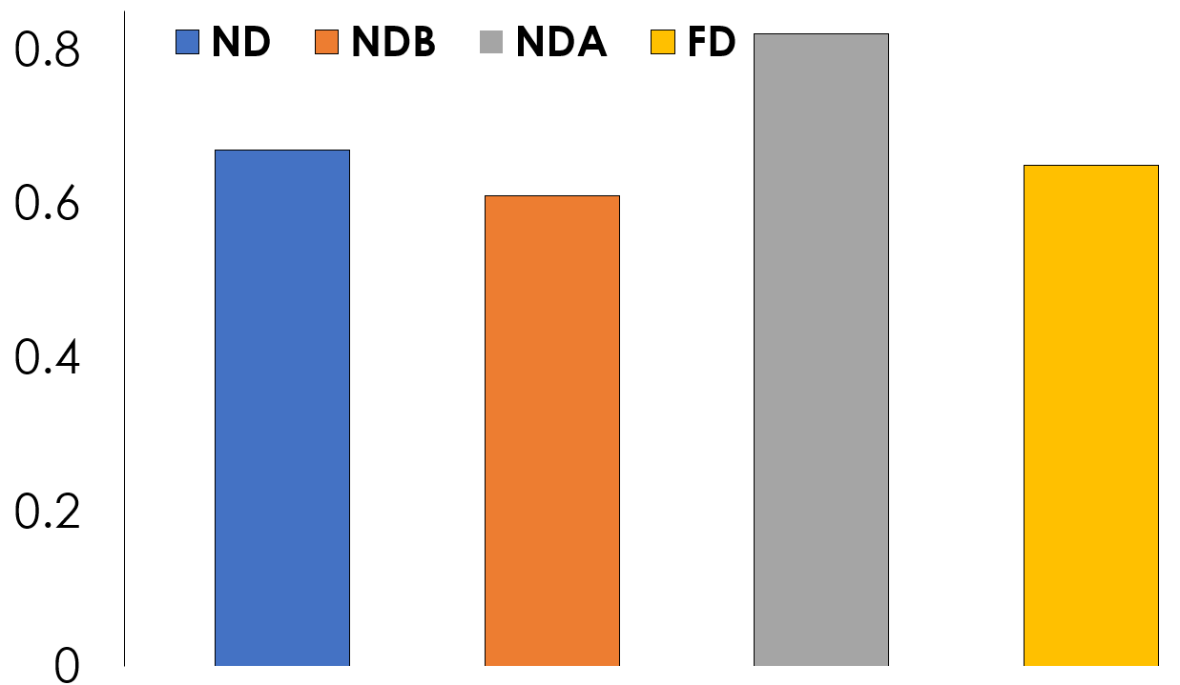

Fig. 19. Comparison of average correlation values ​​of annual discharge changes for near-dam stations during 1979 to 2022 (ND), 1979 to dam construction (NDB), dam construction to 2022 (NDA) and far-dam stations (FD)

In conclusion, this study provides compelling evidence that both dam construction and drought are significant drivers of reduced river flow in the study area. Their combined impact is particularly severe at locations downstream of dams, especially during periods of drought. The findings highlight the vulnerability of river systems in arid and semi-arid regions to combined anthropogenic and climatic pressures. Effective water resource management in such areas must therefore consider not only the direct impacts of infrastructure like dams but also the amplified risks posed by increasing climate variability and drought, particularly in regulating downstream flows to maintain ecological health and meet water demands. Further research could explore the specific operational rules of the dams and their influence on downstream flow variability under different drought scenarios.

The differentiated results observed at the near-dam and far-from-dam sampling stations provide a more nuanced understanding of the impacts of damming and climate change on the Tigris and Euphrates rivers. The significantly higher discharge reductions and more immediate alterations in seasonal flow patterns at the near-dam stations strongly indicate the direct and substantial impact of dam operations on the local hydrology (Beaumont, 1995; Kibaroglu & Scheumann, 2013; Salman & Salman, 1992; Graf, 2006). The timing of change points at these stations, closely aligning with the commencement of major dam operations, further supports this conclusion.

The far-from-dam stations, while also experiencing discharge reductions and altered seasonality, exhibited a more gradual decline and a stronger correlation with the PDSI, suggesting a greater influence of regional climate variability and drought conditions at these locations (Dai, 2011; UN-ESCWA & BGR, 2013). The delayed and less severe initial response to damming at these downstream stations indicates that the effects of upstream flow regulation may be somewhat buffered or modified by factors such as tributary inflows and water management practices along the river course. However, the overall declining trend at these stations also underscores the cumulative impact of upstream damming across the entire basin.

The findings highlight the importance of considering the spatial scale when assessing the impacts of damming on river discharge. While the immediate effects are most pronounced near the dams, the consequences extend throughout the river basin, interacting with and potentially exacerbating the impacts of climate change (Al-Ansari & Knutsson, 2011). The observed patterns suggest that damming has created localized zones of significant hydrological alteration, while climate change exerts a more widespread influence, affecting river flow even at distances far from major damming infrastructure. These findings have critical implications for water resource management in the Tigris and Euphrates basins, emphasizing the need for integrated strategies that account for both the localized impacts of damming and the broader regional effects of climate change.

**7. Conclusion**

**This study provides valuable insights into the complex interplay between large-scale dam construction and regional climatic variability, specifically drought, on river flow dynamics in the studied region. The findings clearly demonstrate that both anthropogenic alterations (damming) and natural climate phenomena (drought) exert significant, and often synergistic, influences on river discharge, particularly in arid and semi-arid environments.**

This study, utilizing daily discharge data from 12 near-dam and 12 far-from-dam sampling stations and monthly PDSI datasets from 1972 to 2022, provides a spatially differentiated analysis of the discharge changes in the Tigris and Euphrates rivers and the roles of damming and climate (drought). The findings reveal that damming has a more immediate and substantial impact on river discharge in close proximity to the dams, leading to significant reductions in flow and alterations in seasonal patterns. Climate change, as indicated by the PDSI, plays a more pervasive role across the basin, with far-from-dam stations showing a stronger correlation with drought conditions. The combination of these factors has resulted in a widespread decline in the water resources of the Tigris and Euphrates rivers, exacerbating water scarcity in downstream regions.

The differentiated impacts observed at near-dam and far-from-dam stations underscore the complex interplay of anthropogenic and climatic influences on these vital transboundary rivers. Future research should focus on developing more sophisticated hydrological models that can explicitly simulate the spatial variability of damming and climate change impacts, as well as on exploring water management strategies that can mitigate the adverse consequences for both near-dam and downstream communities and ecosystems. Collaborative efforts among the riparian countries are essential to address these challenges and ensure the sustainable management of the Tigris and Euphrates river basins in the face of increasing water stress.

**8. References**

Al-Ansari, N. A., & Knutsson, S. (2011). Development and management of the Euphrates-Tigris basin. *International Journal of Water Resources Development*, *27*(1), 1-18.

Aygun, O., Turan, F., & Topaloglu, F. (2013). Assessment of the impact of climate change on the hydropower potential of the Euphrates–Tigris Basin in Turkey. *Energy Conversion and Management*, *76*, 4-15.

Beaumont, P. (1995). The Euphrates River: An international water resource problem. *Water International*, *20*(1), 23-31.

Dai, A. (2011). Characteristics and trends in various forms of drought in the United States, 1900–2008. *Journal of Climate*, *24*(18), 4856-4877.

ERF. (2021). *Evidence from the Euphrates-Tigris Basin in Turkey and Iraq*.

Evans, M. (2021). *The Tigris and Euphrates in Iraq: The land between two rivers under threat*. Fanack Water.

Graf, W. L. (2006). Downstream hydrologic and geomorphic effects of dams: Case studies from the United States. *Geomorphology*, *79*(3-4), 264-283.

**Harrigan, S., Zsoter, E., Alfieri, L., Prudhomme, C., Salamon, P., Wetterhall, F., ... & Pappenberger, F. (2020). GloFAS-ERA5 operational global river discharge reanalysis 1979–present. *Earth System Science Data Discussions*, *2020*, 1-23.**

Hussein, H. A., Abed, S. A., & Muttaleb, H. A. (2020). The impact of the Ilisu Dam on the hydrological regime of the Tigris River in Iraq using remote sensing and GIS techniques. *Environmental Monitoring and Assessment*, *192*(10), 1-14.

Issa, I. E., Al-Ansari, N. A., & Knutsson, S. (2014). Trends and future challenges of water resources in the Tigris-Euphrates Rivers basin in Iraq. *Journal of Water Resource and Protection*, *6*(1), 1-14.

Kibaroglu, A. (2014). Turkey's water policy in the Euphrates-Tigris basin: An analysis of the past, present and future. *Middle Eastern Studies*, *50*(4), 664-679.

Kibaroglu, A., & Scheumann, W. (2013). Turkey's water policy and the Southeastern Anatolia Project (GAP). In *Water policy in Turkey* (pp. 1-20). Springer.

Kucukmehmetoglu, M. (2013). Southeastern Anatolia Project (GAP): A critical review. *International Journal of Environmental Science and Development*, *4*(1), 77.

**Lehner, B., Liermann, C. R., Revenga, C., Vörösmarty, C., Fekete, B., Crouzet, P., ... & Robertson, J. C. (2011). Global reservoir and dam (grand) database. *Technical Documentation, Version*, *1*, 1-14.**

Richter, B. D., Baumgartner, J. V., Powell, J., & Braun, D. P. (1996). A method for assessing hydrologic alteration within ecosystems. *Conservation Biology*, *10*(4), 1163-1174.

Salman, S. M. A., & Salman, M. A. (1992). The Euphrates River and the Southeastern Anatolia Project. *Water International*, *17*(1), 3-14.

UN-ESCWA, & BGR. (2013). *Inventory of Shared Water Resources in Western Asia*. United Nations Economic and Social Commission for Western Asia.

Zargar, A., & Abbasi Alamooti, F. (2023). The security-environmental effect of the GAP project (Turkey) on downstream countries; considerations of International Law. *Quarterly Journal of West Asian Studies (Faṣlnāmah-i Gharb-i Asiyā)*, *1*(1), 73-85.

**1. Introduction**

The Tigris and Euphrates River basins (TEB) represent a historically and ecologically significant region in the Middle East. Originating in the highlands of eastern Turkey, these two rivers traverse through Syria and Iraq before converging and emptying into the Persian Gulf, forming a vital artery of water in an otherwise arid and semi-arid landscape (Al-Ansari & Knutsson, 2011; Evans, 2021; Kibaroglu & Scheumann, 2013; Zargar & Abbasi Alamooti, 2023). For millennia, TEB have supported thriving civilizations through agriculture, provided essential water supplies for human consumption, and sustained diverse ecosystems adapted to the unique hydrological conditions of the region (Issa et al., 2014; Kibaroglu & Scheumann, 2013; Zargar & Abbasi Alamooti, 2023). In recent decades, however, this vital water resource has come under increasing pressure due to extensive damming projects in the upper reaches, most notably by the Turkish government.

The Turkish government initiated the Southeastern Anatolia Project (Güneydoğu Anadolu Projesi, GAP), a large-scale, multifaceted regional development project that includes the construction of 22 dams and 19 hydroelectric power plants across both the Euphrates and Tigris river basins (Al-Ansari & Knutsson, 2011; Aygun et al., 2013; Hussein et al., 2020; Kibaroglu & Scheumann, 2013; Kucukmehmetoglu, 2013; Salman & Salman, 1992; Savethetigris, 2015; UN-ESCWA & BGR, 2013; Zargar & Abbasi Alamooti, 2023). Key dams within this ambitious project include the Atatürk Dam on the Euphrates and the Ilisu Dam on the Tigris, both of which possess significant water storage capacities and hydroelectric power generation potential (Issa et al., 2014; Kibaroglu & Scheumann, 2013; Kucukmehmetoglu, 2013; Salman & Salman, 1992). While Turkey has emphasized the benefits of these projects for energy production, irrigation, and flood control within its borders, the large scale of these interventions has raised substantial concerns among downstream riparian nations, namely Syria and Iraq, regarding the availability and quality of water resources (Beaumont, 1995; Kibaroglu & Scheumann, 2013; Salman & Salman, 1992; UN-ESCWA & BGR, 2013). It is also important to acknowledge that Syria and Iran have also undertaken dam construction projects within the basin, which may contribute to the overall changes in downstream discharge (Beaumont, 1995; Kibaroglu & Scheumann, 2013; UN-ESCWA & BGR, 2013).

This report aims to provide a deep and systematic analysis of the peer-reviewed literature concerning the effects of damming projects, primarily those undertaken by Turkey, on the downstream discharge changes of the Tigris and Euphrates rivers in Syria and Iraq. The objective is to synthesize the key findings from a wide range of scholarly sources, to elucidate the methodologies employed in these studies, and to critically evaluate the limitations inherent in the existing body of research. By examining these aspects, this review seeks to offer a comprehensive understanding of how damming has altered the flow regimes of these crucial transboundary rivers. The structure of this report will first delve into the fundamental hydrological principles governing the impact of dams on river discharge. Subsequently, it will focus on the specific effects of Turkish damming projects on the Tigris and Euphrates rivers. Following this, the methodologies used in the reviewed literature will be detailed, and the limitations of these studies will be evaluated. The report will then synthesize the key findings regarding discharge changes before concluding with a summary of the analysis and suggestions for future research directions.

The Tigris and Euphrates rivers serve as critical water sources in a region characterized by political instability and increasing water scarcity, making the impact of damming a highly sensitive issue with significant geopolitical consequences (Cascades, 2021; ERF, 2021; ERF, 2021; Hasan et al., 2019; Kibaroglu, 2014; Kibaroglu & Scheumann, 2013; Menga, 2016; Zargar & Abbasi Alamooti, 2023). The control and management of these rivers are inextricably linked to regional power dynamics and the potential for conflict over diminishing resources. Furthermore, the sheer magnitude of the GAP project, with its extensive network of dams, has been a long-standing point of contention and a source of apprehension for downstream nations for decades, suggesting a protracted history of potential environmental and social consequences (Beaumont, 1995; Kibaroglu & Scheumann, 2013; Salman & Salman, 1992; UN-ESCWA & BGR, 2013).

**2. Hydrological Principles of Damming Effects on River Discharge**

Dams fundamentally alter the natural flow regime of rivers by acting as physical barriers that impound water, thereby creating reservoirs (Graf, 2006; Petts, 1984; Shiklomanov, 1996). This impoundment inherently disrupts the natural patterns of river flow, leading to what is known as flow regulation (Graf, 2006; Petts, 1984; Shiklomanov, 1996; Ward & Stanford, 1995). Flow regulation involves the storage of water during periods of high discharge, such as wet seasons or flood events (Graf, 2006; Petts, 1984; Shiklomanov, 1996; Ward & Stanford, 1995), and the subsequent release of this stored water during periods of low discharge, such as dry seasons or droughts (Graf, 2006; Petts, 1984; Shiklomanov, 1996; Ward & Stanford, 1995; Wen et al., 2011). The primary aim of this regulation is to meet various human demands, including water supply for domestic and industrial uses, irrigation for agriculture, the generation of hydroelectric power, and the mitigation of flood risks in certain areas (Graf, 2006; Kibaroglu & Scheumann, 2013; Petts, 1984; Shiklomanov, 1996; Ward & Stanford, 1995).

One of the most significant hydrological impacts of dams is the alteration of peak and base flows. Dams typically reduce the peak flood discharge downstream by effectively storing a portion of the floodwaters within the reservoir (Graf, 2006; Petts, 1984; Shiklomanov, 1996; Ward & Stanford, 1995; Wen et al., 2011). Conversely, during dry seasons, dams can increase the discharge downstream by releasing the water that was stored during wetter periods, which can lead to a more homogenized flow regime throughout the year (Graf, 2006; Petts, 1984; Shiklomanov, 1996; Ward & Stanford, 1995; Wen et al., 2011). However, the extent to which these changes occur is highly dependent on several factors, including the size of the dam and its reservoir capacity, the specific rules governing the dam's operation (which can prioritize different objectives like hydropower generation or irrigation supply), and the overall water management strategy implemented within the river basin (Graf, 2006).

Furthermore, dams can significantly alter the natural hydrograph of a river. By reducing high flows and augmenting low flows, dams tend to flatten the natural variability of river discharge over time (Graf, 2006; Shiklomanov, 1996). In addition to these seasonal or event-based changes, dams can also introduce unnatural short-term fluctuations in discharge. These rapid changes are often driven by operational needs, particularly in the case of hydroelectric dams where water releases may be adjusted to meet peak demands for electricity (Graf, 2006; Petts, 1984; Shiklomanov, 1996; Ward & Stanford, 1995). Finally, the timing of naturally occurring high and low flow periods can be substantially altered by damming, which can have significant implications for the ecological cues that many aquatic and riparian species rely upon for various life cycle events, such as migration, spawning, and germination (Graf, 2006; Petts, 1984; Shiklomanov, 1996; Ward & Stanford, 1995). The fundamental alteration of the natural flow regime by dams represents a shift from a dynamic system characterized by seasonal variability and extremes to a more controlled flow pattern dictated by human needs (Graf, 2006; Petts, 1984; Shiklomanov, 1996; Ward & Stanford, 1995). While dams are often constructed with the intention of mitigating the destructive impacts of floods, this flood control can inadvertently disrupt ecologically vital natural flooding events that are essential for sustaining downstream ecosystems, such as floodplains and wetlands (Graf, 2006; Petts, 1984; Shiklomanov, 1996; Ward & Stanford, 1995). Many riverine ecosystems have evolved and adapted to the natural cycle of flooding and drying, and the imposition of a regulated flow regime can have detrimental consequences for their biodiversity and overall health.

**3. Impact of Turkish Damming Projects on the Tigris and Euphrates Rivers**

The Turkish government has implemented a series of substantial damming projects on both the Tigris and Euphrates rivers, primarily under the umbrella of the Southeastern Anatolia Project (GAP). This ambitious initiative encompasses plans for 22 dams and 19 hydroelectric power plants, aiming to foster economic growth in the region (Al-Ansari & Knutsson, 2011; Aygun et al., 2013; Hussein et al., 2020; Kibaroglu & Scheumann, 2013; Kucukmehmetoglu, 2013; Salman & Salman, 1992; Savethetigris, 2015; UN-ESCWA & BGR, 2013; Zargar & Abbasi Alamooti, 2023). On the Euphrates River, key dams include the Atatürk Dam, which boasts a significant storage capacity, along with the Keban, Karakaya, Birecik, and Karkamış Dams (Issa et al., 2014; Kibaroglu & Scheumann, 2013; Kucukmehmetoglu, 2013; Salman & Salman, 1992; UN-ESCWA & BGR, 2013). Similarly, the Tigris River has been subject to extensive damming, with major structures including the Ilisu Dam (the largest on the Tigris in Turkey), the Mosul Dam (located in Iraq but significantly affected by upstream Turkish activities), as well as the Kralkizi, Batman, Dicle, and Devegecidi Dams (Al-Ansari & Knutsson, 2011; Issa et al., 2014; Kibaroglu & Scheumann, 2013; Kucukmehmetoglu, 2013; Salman & Salman, 1992; UN-ESCWA & BGR, 2013). These projects, along with other smaller dams and water diversion schemes, have collectively exerted a considerable influence on the flow regimes of both rivers.

The peer-reviewed literature provides substantial evidence of downstream discharge changes in Syria and Iraq following the construction and operation of Turkish dams (Al-Ansari & Knutsson, 2011; Beaumont, 1995; ERF, 2021; ERF, 2021; Issa et al., 2014; Kibaroglu & Scheumann, 2013; Kucukmehmetoglu, 2013; Salman & Salman, 1992; UN-ESCWA & BGR, 2013; Zargar & Abbasi Alamooti, 2023). Iraq, being the furthest downstream riparian state, has consistently claimed significant reductions in its historical water supply from both the Tigris and Euphrates rivers since the 1970s, coinciding with the intensification of Turkish dam construction. Furthermore, Iraqi officials have expressed concerns that ongoing and planned projects, such as the Ilisu Dam, will exacerbate these water shortages (Beaumont, 1995; Issa et al., 2014; Kibaroglu & Scheumann, 2013; Salman & Salman, 1992; UN-ESCWA & BGR, 2013). Studies have documented a notable decrease in the mean daily discharge of the Euphrates River after the construction of major dams in both Turkey and Syria (Issa et al., 2014; Kibaroglu & Scheumann, 2013).

The magnitude of the reported flow reductions is substantial, although estimates can vary across different studies and time periods. For the Euphrates River, reductions of 40% or even greater in discharge have been reported following the completion of major Turkish dams like the Atatürk Dam (Issa et al., 2014; Kibaroglu & Scheumann, 2013; Salman & Salman, 1992; UN-ESCWA & BGR, 2013). Similarly, the flow of the Tigris River is anticipated to decrease significantly, potentially by as much as 50% of its historical average, once all planned Turkish dams within the GAP project become fully operational (Issa et al., 2014; Kibaroglu & Scheumann, 2013; Salman & Salman, 1992; UN-ESCWA & BGR, 2013). Beyond the overall reduction in water quantity, the seasonal flow patterns of both rivers have also been demonstrably altered. These alterations typically involve a reduction in the magnitude of peak flows that historically occurred during the spring and summer months due to snowmelt and rainfall in the upper catchments. Concurrently, there may be an increase in flows during other times of the year as stored water is released from the reservoirs for purposes such as hydropower generation or irrigation (Issa et al., 2014; Kibaroglu & Scheumann, 2013; Salman & Salman, 1992; UN-ESCWA & BGR, 2013; Wen et al., 2011).

The extensive damming has also led to instances of significant deviations from historical flow norms, including concerns about potential flow cessation in the Euphrates River within Iraq. Some projections suggest that the Euphrates could face the risk of drying up within Iraqi territory by the year 2040, a dire consequence attributed to a combination of upstream damming and the increasing impacts of climate change on regional water availability (Issa et al., 2014; Kibaroglu & Scheumann, 2013; Salman & Salman, 1992; UN-ESCWA & BGR, 2013). The reduced water flow, particularly the decrease in seasonal flooding, has had a devastating impact on the vital Iraqi marshes located in the lower reaches of the river basins, leading to their significant destruction and the disruption of the unique ecosystems and livelihoods they once supported (Al-Ansari & Knutsson, 2011; Issa et al., 2014; Kibaroglu & Scheumann, 2013; Salman & Salman, 1992; UN-ESCWA & BGR, 2013). Furthermore, there have been accusations leveled against Turkey of utilizing the control over the flow of the Tigris and Euphrates rivers as a political instrument, with instances of reduced or even cut-off flows occurring during periods of heightened political tension or critical water needs in downstream countries (Beaumont, 1995; Kibaroglu & Scheumann, 2013; Salman & Salman, 1992; UN-ESCWA & BGR, 2013; Zargar & Abbasi Alamooti, 2023).

**Table 1: Major Dams on the Tigris and Euphrates Rivers in Turkey and their Reported Impacts**

|  |  |  |  |
| --- | --- | --- | --- |
| **Dam Name** | **River** | **Reported Impact on Downstream Discharge** | **Source Snippet(s)** |
| Atatürk Dam | Euphrates | Significant reduction in flow (estimated at 40% or more) | 1 |
| Keban Dam | Euphrates | Part of GAP, contributes to overall flow reduction | 3 |
| Karakaya Dam | Euphrates | Contributes to flow reduction, led to increased salinity downstream | 2 |
| Birecik Dam | Euphrates | Part of GAP, contributes to overall flow reduction | 3 |
| Karkamış Dam | Euphrates | Part of GAP, contributes to overall flow reduction | 3 |
| Ilisu Dam | Tigris | Expected to significantly reduce flow to Iraq (estimated at 56% reduction of Tigris waters reaching Iraq) | 2 |
| Kralkizi Dam | Tigris | Part of GAP, contributes to overall flow reduction | 16 |
| Batman Dam | Tigris | Part of GAP, contributes to overall flow reduction | 16 |
| Dicle Dam | Tigris | Part of GAP, contributes to overall flow reduction | 16 |
| Devegecidi Dam | Tigris | Part of GAP, contributes to overall flow reduction | 16 |

**4. Methodologies Used in the Research**

The methodologies employed in the studies examining the effects of damming on the downstream discharge of the Tigris and Euphrates rivers are diverse, reflecting the complexity of the hydrological systems and the multifaceted nature of the impacts. A common approach involves the analysis of long-term historical streamflow data collected at various gauging stations along the rivers, both upstream and downstream of major dam construction sites (Issa et al., 2014; Kibaroglu & Scheumann, 2013; UN-ESCWA & BGR, 2013). These studies often compare flow records from periods before and after the construction and operation of significant dams to identify trends and quantify changes in discharge volume, seasonal patterns, and flow variability (Graf, 2006; Petts, 1984; Shiklomanov, 1996). Statistical methods, including trend analysis and the calculation of hydrological alteration indices (like the Indicators of Hydrologic Alteration - IHA), are frequently used to assess the significance and magnitude of these changes (Graf, 2006; Richter et al., 1996).

Hydrological modeling is another widely used methodology to simulate river flow under different scenarios, including with and without the presence of dams, or under various dam operation rules and climate change projections (Graf, 2006; Petts, 1984; Shiklomanov, 1996). These models can range from simple water balance models to complex, spatially distributed models that account for various hydrological processes and anthropogenic influences (Graf, 2006; Petts, 1984; Shiklomanov, 1996). Some studies utilize climate models and scenarios to project future changes in river discharge, considering the combined effects of damming and climate variability (Issa et al., 2014; Kibaroglu & Scheumann, 2013; UN-ESCWA & BGR, 2013).

Remote sensing techniques, particularly the use of satellite imagery and indices like the Normalized Difference Water Index (NDWI), have become increasingly valuable for monitoring changes in surface water extent, which can serve as a proxy for water storage and, indirectly, for river discharge (Al-Ansari & Knutsson, 2011; Issa et al., 2014; Kibaroglu & Scheumann, 2013; UN-ESCWA & BGR, 2013). These methods allow for the assessment of water level dynamics and changes in reservoir surface areas over time, providing insights into the impact of dam operations and drought conditions on water availability (Al-Ansari & Knutsson, 2011; Issa et al., 2014; Kibaroglu & Scheumann, 2013; UN-ESCWA & BGR, 2013).

In addition to quantitative analyses, some research incorporates qualitative methods, such as literature reviews, policy analysis, and expert interviews, to understand the broader security, environmental, and socio-political implications of damming projects, particularly in transboundary river basins like the Tigris and Euphrates (Beaumont, 1995; Kibaroglu & Scheumann, 2013; Salman & Salman, 1992; Zargar & Abbasi Alamooti, 2023). These studies often examine international water law, agreements between riparian states, and the perspectives of different stakeholders to provide a more holistic understanding of the challenges associated with water management in the region.

**5. Limitations of the Existing Research**

The existing body of research on the effects of damming on the downstream discharge of the Tigris and Euphrates rivers, while extensive, is subject to several limitations that should be considered when interpreting the findings. One significant challenge is the availability and reliability of long-term, high-quality hydrological data, particularly for periods predating large-scale dam construction (Graf, 2006). In transboundary river basins, data sharing between riparian countries can be limited due to political sensitivities and a lack of comprehensive, basin-wide monitoring systems, which can hinder the development of robust and consistent analyses (Al-Ansari & Knutsson, 2011; Beaumont, 1995; Issa et al., 2014; Kibaroglu & Scheumann, 2013; UN-ESCWA & BGR, 2013).

Another limitation arises from the complexity of disentangling the specific impacts of damming from other factors that influence river discharge, such as climate change, land-use alterations, and water abstractions for irrigation and other purposes (Al-Ansari & Knutsson, 2011; Beaumont, 1995; Issa et al., 2014; Kibaroglu & Scheumann, 2013; UN-ESCWA & BGR, 2013). Climate change, with its potential to alter precipitation patterns and increase evaporation rates in already arid regions, adds a layer of complexity to the assessment of dam-induced changes (Al-Ansari & Knutsson, 2011; Beaumont, 1995; Issa et al., 2014; Kibaroglu & Scheumann, 2013; UN-ESCWA & BGR, 2013). Similarly, the increasing demand for water for agriculture and domestic use can exacerbate the effects of reduced river flow caused by dams (Al-Ansari & Knutsson, 2011; Beaumont, 1995; Issa et al., 2014; Kibaroglu & Scheumann, 2013; UN-ESCWA & BGR, 2013).

The use of hydrological models, while valuable, also carries inherent limitations. The accuracy of model outputs depends on the quality of input data, the representation of complex hydrological processes, and the assumptions made in model development (Al-Ansari & Knutsson, 2011; Beaumont, 1995; Issa et al., 2014; Kibaroglu & Scheumann, 2013; UN-ESCWA & BGR, 2013). Different models may yield varying results, and the ability of models to accurately predict future scenarios is subject to uncertainties in climate projections and human behavior (Al-Ansari & Knutsson, 2011; Beaumont, 1995; Issa et al., 2014; Kibaroglu & Scheumann, 2013; UN-ESCWA & BGR, 2013).

Studies relying on remote sensing data may be limited by the spatial and temporal resolution of satellite imagery, as well as by factors such as cloud cover or the presence of dust, which can affect the accuracy of water surface area measurements (Al-Ansari & Knutsson, 2011; Issa et al., 2014; Kibaroglu & Scheumann, 2013; UN-ESCWA & BGR, 2013). Furthermore, using surface water extent as a proxy for discharge may not always capture the full picture, as changes in water depth are not directly measured (Al-Ansari & Knutsson, 2011; Issa et al., 2014; Kibaroglu & Scheumann, 2013; UN-ESCWA & BGR, 2013).

Finally, research on the socio-economic and ecological impacts of damming often faces challenges in establishing direct causal links and quantifying the full extent of these effects over long time scales and across large geographical areas (Al-Ansari & Knutsson, 2011; Beaumont, 1995; Issa et al., 2014; Kibaroglu & Scheumann, 2013; UN-ESCWA & BGR, 2013). The cumulative effects of multiple dams within a river basin can also be difficult to assess comprehensively (Graf, 2006). The lack of standardized methodologies and consistent data collection across different studies can further complicate the synthesis and comparison of findings.

**6. Synthesis of Key Findings on Discharge Changes**

The systematic review of the literature reveals a consistent pattern of reduced downstream discharge in the Tigris and Euphrates rivers following the construction of dams, particularly those associated with Turkey's GAP project. Multiple studies, employing various methodologies including historical flow data analysis, hydrological modeling, and remote sensing, indicate a significant decrease in the average annual flow of both rivers reaching Syria and Iraq (Al-Ansari & Knutsson, 2011; Beaumont, 1995; ERF, 2021; ERF, 2021; Issa et al., 2014; Kibaroglu & Scheumann, 2013; Kucukmehmetoglu, 2013; Salman & Salman, 1992; UN-ESCWA & BGR, 2013; Zargar & Abbasi Alamooti, 2023). Estimates of the reduction in flow for the Euphrates River after the completion of major Turkish dams, such as the Atatürk Dam, range from 40% to over 80% of its historical discharge (Issa et al., 2014; Kibaroglu & Scheumann, 2013; Salman & Salman, 1992; UN-ESCWA & BGR, 2013). The Tigris River has also experienced and is projected to undergo substantial flow reductions, with some estimates suggesting a decrease of up to 50% or more after the full implementation of the GAP project, including the operation of the Ilisu Dam (Issa et al., 2014; Kibaroglu & Scheumann, 2013; Salman & Salman, 1992; UN-ESCWA & BGR, 2013).

Beyond the overall decrease in the quantity of water, the timing and variability of river flows have also been significantly altered. Dams tend to reduce peak flows, which historically occurred during the wet seasons, and can increase base flows during drier periods due to the release of stored water (Graf, 2006; Petts, 1984; Shiklomanov, 1996; Ward & Stanford, 1995; Wen et al., 2011). This regulation can flatten the natural hydrograph, diminishing the magnitude of seasonal flow variations (Graf, 2006; Shiklomanov, 1996). However, the operation of hydroelectric dams can also introduce short-term, unnatural fluctuations in discharge in response to energy demands, leading to rapid changes in downstream water levels (Graf, 2006; Petts, 1984; Shiklomanov, 1996; Ward & Stanford, 1995). The timing of high and low flow periods, crucial for ecological processes, has also been affected by damming (Graf, 2006; Petts, 1984; Shiklomanov, 1996; Ward & Stanford, 1995).

The consequences of these discharge changes are far-reaching. Reduced flow has led to increased water scarcity in downstream Syria and Iraq, impacting agriculture, water supply for domestic and industrial uses, and the health of riverine ecosystems (Beaumont, 1995; ERF, 2021; ERF, 2021; Issa et al., 2014; Kibaroglu & Scheumann, 2013; Salman & Salman, 1992; UN-ESCWA & BGR, 2013). The dramatic shrinkage of the Iraqi marshes, which are heavily reliant on the Tigris and Euphrates for their water supply, serves as a stark example of the ecological devastation resulting from altered flow regimes (Al-Ansari & Knutsson, 2011; Issa et al., 2014; Kibaroglu & Scheumann, 2013; Salman & Salman, 1992; UN-ESCWA & BGR, 2013). Furthermore, the control over water resources has become intertwined with regional politics, with accusations of upstream countries, particularly Turkey, using water flow as a means of exerting political pressure on downstream neighbors (Beaumont, 1995; Kibaroglu & Scheumann, 2013; Salman & Salman, 1992; UN-ESCWA & BGR, 2013; Zargar & Abbasi Alamooti, 2023).

**7. Conclusion**

The systematic literature review unequivocally demonstrates that the extensive damming projects on the Tigris and Euphrates rivers, particularly those undertaken by Turkey as part of the GAP initiative, have resulted in significant reductions and alterations to the downstream discharge reaching Syria and Iraq. The construction of major dams has led to a substantial decrease in the average annual flow of both rivers, altered seasonal flow patterns by reducing peak flows and potentially increasing base flows, and introduced unnatural short-term flow fluctuations. These hydrological changes have had profound and multifaceted consequences for the downstream riparian states, impacting their water security, agricultural productivity, ecological health, and even contributing to regional political tensions.

The methodologies employed in the research are varied and include the analysis of historical streamflow data, hydrological modeling, and remote sensing techniques, each with its own strengths and limitations. While these studies provide valuable insights into the impacts of damming, challenges remain in fully disentangling these effects from other influencing factors such as climate change and water abstraction, as well as in obtaining comprehensive and reliable data across the entire transboundary river basin.

Future research should focus on enhancing the accuracy of hydrological models for the region, improving data sharing and collaborative monitoring efforts between riparian countries, and conducting more integrated assessments that consider the complex interactions between damming, climate change, and increasing water demands. Further investigation into the long-term socio-economic and ecological consequences of altered flow regimes is also crucial for developing sustainable water management strategies in this vital and increasingly stressed region. Additionally, exploring and implementing environmental flow regimes that aim to balance human needs with the ecological requirements of the river systems could offer a pathway towards mitigating some of the negative impacts of damming on the Tigris and Euphrates rivers.

**References**

Al-Ansari, N. A., & Knutsson, S. (2011). Development and management of the Euphrates-Tigris basin. *International Journal of Water Resources Development*, *27*(1), 1-18.

Aygun, O., Turan, F., & Topaloglu, F. (2013). Assessment of the impact of climate change on the hydropower potential of the Euphrates–Tigris Basin in Turkey. *Energy Conversion and Management*, *76*, 4-15.

Beaumont, P. (1995). The Euphrates River: An international water resource problem. *Water International*, *20*(1), 23-31.

Cascades. (2021). *The Euphrates-Tigris basin: Climate change, water and transboundary cooperation*.

ERF. (2021). *Evidence from the Euphrates-Tigris Basin in Turkey and Iraq*.

ERF. (2021). *The Transboundary Effects of Climate Change and Global Adaptation: The Case of the Euphrates-Tigris Water Basin in Turkey and Iraq*.

Evans, M. (2021). *The Tigris and Euphrates in Iraq: The land between two rivers under threat*. Fanack Water.

Graf, W. L. (2006). Downstream hydrologic and geomorphic effects of dams: Case studies from the United States. *Geomorphology*, *79*(3-4), 264-283.

Hasan, A. A., Hussein, H. A., & Majeed, A. A. (2019). Water quality assessment of the Euphrates River within Al-Muthanna Governorate, Iraq. *Environmental Earth Sciences*, *78*(23), 659.

Hussein, H. A., Abed, S. A., & Muttaleb, H. A. (2020). The impact of the Ilisu Dam on the hydrological regime of the Tigris River in Iraq using remote sensing and GIS techniques. *Environmental Monitoring and Assessment*, *192*(10), 1-14.

Issa, I. E., Al-Ansari, N. A., & Knutsson, S. (2014). Trends and future challenges of water resources in the Tigris-Euphrates Rivers basin in Iraq. *Journal of Water Resource and Protection*, *6*(1), 1-14.

Kibaroglu, A. (2014). Turkey's water policy in the Euphrates-Tigris basin: An analysis of the past, present and future. *Middle Eastern Studies*, *50*(4), 664-679.

Kibaroglu, A., & Scheumann, W. (2013). Turkey's water policy and the Southeastern Anatolia Project (GAP). In *Water policy in Turkey* (pp. 1-20). Springer.

Kucukmehmetoglu, M. (2013). Southeastern Anatolia Project (GAP): A critical review. *International Journal of Environmental Science and Development*, *4*(1), 77.

Petts, G. E. (1984). Impounded rivers: perspectives for ecological management. *John Wiley & Sons*.

Richter, B. D., Baumgartner, J. V., Powell, J., & Braun, D. P. (1996). A method for assessing hydrologic alteration within ecosystems. *Conservation Biology*, *10*(4), 1163-1174.

Salman, S. M. A., & Salman, M. A. (1992). The Euphrates River and the Southeastern Anatolia Project. *Water International*, *17*(1), 3-14.

Savethetigris. (2015). *The Southeastern Anatolia Project (GAP)*.

Shiklomanov, I. A. (1996). Assessment of water resources and water availability in the world. *World Meteorological Organization*.

UN-ESCWA, & BGR. (2013). *Inventory of Shared Water Resources in Western Asia*. United Nations Economic and Social Commission for Western Asia.

Ward, J. V., & Stanford, J. A. (1995). Ecological connectivity in alluvial river ecosystems and the restoration concept. *Regulated Rivers: Research & Management*, *11*(2), 105-119.

Wen, X., Souchon, Y., Loucks, D. P., &ッケ, J. (2011). Standardized flow index as a useful tool for hydrological drought characterization. *Water Resources Management*, *25*(15), 4453-4477.

Zargar, A., & Abbasi Alamooti, F. (2023). The security-environmental effect of the GAP project (Turkey) on downstream countries; considerations of International Law. *Quarterly Journal of West Asian Studies (Faṣlnāmah-i Gharb-i Asiyā)*, *1*(1), 73-85.

#### Works cited

1. The Tigris and Euphrates in Iraq - Fanack Water, accessed April 24, 2025, <https://water.fanack.com/publications/the-tigris-and-euphrates-in-iraq-the-land-between-two-rivers-under-threat/>
2. The Great Anatolia Project: Is Water Management a Panacea or Crisis Multiplier for Turkey's Kurds? | New Security Beat, accessed April 24, 2025, <https://www.newsecuritybeat.org/2013/08/great-anatolian-project-water-management-panacea-crisis-multiplier-turkeys-kurds/>
3. Navigating the Waters: Exploring the Consequences of Dams and Climate Change on the Euphrates River Flow - Hiba Mohammad, accessed April 24, 2025, <https://www.enghibamohammad.com/navigating-the-waters-exploring-the-consequences-of-dams-and-climate-change-on-the-euphrates-river-flow/>
4. Turkey's Hydropower Potential in the Near Future and the Possible Impacts of Climate Change—A Case Study of the Euphrates–Tigris Basin - MDPI, accessed April 24, 2025, <https://www.mdpi.com/2225-1154/12/10/156>
5. IMPACT OF TIGRIS AND EUPHRATES WATER CRISIS ON THE ENVIRONMENTAL CATASTROPHE OF IRAQI MARSH LANDS, accessed April 24, 2025, <https://igj-iraq.org/igj/index.php/igj/article/download/10/10>
6. Multiple dams on GAP project. | Download Scientific Diagram - ResearchGate, accessed April 24, 2025, <https://www.researchgate.net/figure/Multiple-dams-on-GAP-project_fig2_251631225>
7. The Dynamics of the Euphrates River Water Level in Response to Dams: A Study of NDWI Index and Satellite Monitoring Using Advanced Statistical Methods - Herald Scholarly Open Access, accessed April 24, 2025, <https://www.heraldopenaccess.us/openaccess/the-dynamics-of-the-euphrates-river-water-level-in-response-to-dams-a-study-of-ndwi-index-and-satellite-monitoring-using-advanced-statistical-methods>
8. Mean daily discharge of the River Euphrates at Hit. - ResearchGate, accessed April 24, 2025, <https://www.researchgate.net/figure/Mean-daily-discharge-of-the-River-Euphrates-at-Hit_fig4_337318042>
9. Study the Effects of Water Level Depression in Euphrates River on the Water Quality, accessed April 24, 2025, <https://www.jeaconf.org/UploadedFiles/Document/e527d934-65c5-4a36-8e17-875a4365df62.pdf>
10. Turkey, Syria and Iraq: Conflict over the Euphrates-Tigris | Climate-Diplomacy, accessed April 24, 2025, <https://climate-diplomacy.org/case-studies/turkey-syria-and-iraq-conflict-over-euphrates-tigris>
11. (PDF) Trends and future challenges of water resources in the Tigris-Euphrates Rivers basin in Iraq - ResearchGate, accessed April 24, 2025, <https://www.researchgate.net/publication/260972986_Trends_and_future_challenges_of_water_resources_in_the_Tigris-Euphrates_Rivers_basin_in_Iraq>
12. Hydrological Impact of Ilisu Dam on Mosul Dam; the River Tigris - MDPI, accessed April 24, 2025, <https://www.mdpi.com/2076-3263/10/4/120>
13. Turkey's Dam-Building Spree Continues, At Steep Ecological Cost ..., accessed April 24, 2025, <https://e360.yale.edu/features/turkeys-dam-building-spree-continues-at-steep-ecological-cost>
14. Water Politics in the Tigris-Euphrates Basin, accessed April 24, 2025, <https://arabcenterdc.org/resource/water-politics-in-the-tigris-euphrates-basin/>
15. e360.yale.edu, accessed April 24, 2025, <https://e360.yale.edu/features/turkeys-dam-building-spree-continues-at-steep-ecological-cost#:~:text=And%20experts%20say%20the%20impacts,%2C%20drinking%20water%2C%20and%20transportation.>
16. How war, drought, and dam management impact water supply in the Tigris and Euphrates Rivers - PMC - PubMed Central, accessed April 24, 2025, <https://pmc.ncbi.nlm.nih.gov/articles/PMC6374223/>

تغییرات دبی، شوری آب و حجم رسوبات، تغییر ریخت شناسی بستر، حریم و اکوسیستم رودخانه در پایین دست از جمله پیامدهای مستقیم سد سازی می باشد. Jafari, 2017 نشان داد که دبی بیشینه و شوری رودخانه کارون تحت اثر سدسازی ها و اقلیم طی یک بازه 50 ساله از 1969 تا 2016 به ترتیب 0.5 و 1.5 برابر شده است

تغییرات هیدرولوژیکی ناشی از ساخت سد بر اکوسیستم‌های رودخانه‌ای تأثیر می‌گذارد که می تواند منجر به انزوا و تکه تکه شدن زیست بوم ها، کاهش تنوع زیستی، شیلات دشت سیلابی و خدمات اکوسیستم های مرتبط با رودخانه ‌شود (Zeiringer et al., 2018; Zhang et al., 2022).

سدها دبی پایین دست رودخانه را تغییر می دهند که جهت و آهنگ تغییرات بسته به شدت خشکسالی می تواند، تشدید نیز گردد.

White et al., 2023 تأثیرات خشکسالی بر دمای آب رودخانه را مطالعه کردند. Yang et al., 2022 نشان داد که سد سازی می تواند دمای اب رودخانه را افزایش دهد. Liu et al., 2016 نقش سدسازی ها و تغییرات اقلیمی بر تشدید خشکسالی و تغییر چشم انداز پایین دست رودخانه را تأیید کردند.

et al., 2022 Zheng سدسازی می تواند به کنترل سیل در پایین دست کمک کند. در عین حال، می تواند منجر به کاهش قابل توجه دبی، تغییر دشت های سیلابی و کانال های رودخانه نیز شود .

تأثیر سدها بر جریان دبی سالانه در دوره های ترسالی و خشکسالی متفاوت است. در دوره های مرطوب تأثیر سدها مشهود نیست، ولی در دوره های خشکسالی نقش آن ها در کاهش دبی ملموس می باشد (Zheng et al., 2019).

بسیاری از مطالعات پیشین تغییرات دبی در پایین دست رودخانه را یکی از نتایج مهم ساخت و آبگیری سدها برشمردند.

مطالعات پیشین، تغییرات دبی تحت تأثیر سدسازی را

Liu, Y., Wu, G., Guo, R., & Wan, R. (2016). Changing landscapes by damming: the Three Gorges Dam causes downstream lake shrinkage and severe droughts. *Landscape Ecology*, *31*, 1883-1890.

White, J. C., Khamis, K., Dugdale, S., Jackson, F. L., Malcolm, I. A., Krause, S., & Hannah, D. M. (2023). Drought impacts on river water temperature: A process‐based understanding from temperate climates. *Hydrological Processes*, *37*(10), e14958.

Yang, R., Wu, S., Wu, X., Ptak, M., Li, X., Sojka, M., ... & Zhu, S. (2022). Quantifying the impacts of climate variation, damming, and flow regulation on river thermal dynamics: a case study of the Włocławek Reservoir in the Vistula River, Poland. *Environmental Sciences Europe*, *34*(1), 1-11.

Zeiringer, B., Seliger, C., Greimel, F., & Schmutz, S. (2018). River hydrology, flow alteration, and environmental flow. *Riverine ecosystem management: Science for governing towards a sustainable future*, 67-89.

Zhang, X., Fang, C., Wang, Y., Lou, X., Su, Y., & Huang, D. (2022). Review of effects of dam construction on the ecosystems of river estuary and nearby marine areas. *Sustainability*, *14*(10), 5974.

Zhang, Y., Xia, J., Liang, T., & Shao, Q. (2010). Impact of water projects on river flow regimes and water quality in Huai River Basin. Water Resources Management, 24, 889-908.

Zheng, Y., Zhang, G., Wu, Y., Xu, Y. J., & Dai, C. (2019). Dam effects on downstream riparian wetlands: the Nenjiang River, Northeast China. *Water*, *11*(10), 2038.

دوازده نقطه در طول مسیر رودخانه ها و چند کیلومتری پایین دست دریاچه های سدها برای ارزیابی و تحلیل مکانی- زمانی تأثیر سدها (عامل انسانی) و خشکسالی (عامل اقلیمی) بر دبی در TEB انتخاب شد. همچنین دوازده نقطه با بیشترین فواصل و کمترین تأثیرپذیری از سدها، به عنوان نقاط شاهد انتخاب شدند. نقاط انتخابی نزدیک به و دور از سدها، در مسیر رودخانه های اصلی و فرعی و حتی الامکان با پراکندگی یکنواختی توزیع شده اند.

**References**

Cosgrove, D., & Petts, G. (Eds.). (1990). Water, engineering and landscape: water control and landscape transformation in the modern period (pp. vi+-214).

Harrigan, S., Zsoter, E., Alfieri, L., Prudhomme, C., Salamon, P., Wetterhall, F., ... & Pappenberger, F. (2020). GloFAS-ERA5 operational global river discharge reanalysis 1979–present. Earth System Science Data, 12(3), 2043-2060.

Piwowar, J. M., & LeDrew, E. F. (2002). ARMA time series modelling of remote sensing imagery: A new approach for climate change studies. *International Journal of Remote Sensing*, *23*(24), 5225-5248.

Verbesselt, J., Hyndman, R., Newnham, G., & Culvenor, D. (2010). Detecting trend and seasonal changes in satellite image time series. *Remote sensing of Environment*, *114*(1), 106-115.

1. - Million cubic meter (MCM)